ST. LAWRENCE 0208 890 2367
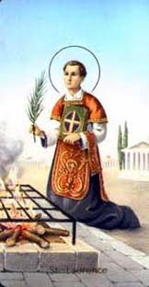
CATHOLIC CHURCH email: feltham@rcdow.org.uk
FELTHAM web:www.saintlawrences.org.uk
The Green, Feltham TW13 4AF
Facebook Group: St Lawrences RC Church, Feltham

Sixth Sunday of Easter 16th/17th May 2020
Readings: Parish Mass Book Year A, Volume 1: Page 268: Acts 8:5-8; 14-17, Psalm 65; 1 Peter 3:15-18; John 14:15-21
The Ascension of the Lord (Thursday 21st May): Page 272
Next Week: 7th Sunday of Easter: Page 275: Acts 1:12-14; Psalm 26; 1 Peter 4:13-16; John 17:1-11

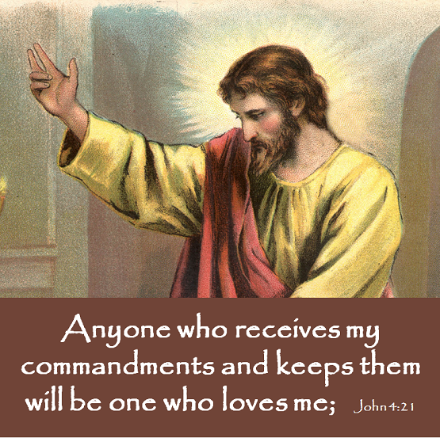
Parish Team
Parish Priest:
Fr. John Byrne
Mobile: 0787 905 8732
Email: johnbyrne@rcdow.org.uk

Assistant Priest:
Fr John Louis Tabor
Email: johntabor@rcdow.org.uk

Deacon:
Rev. Colin Macken
Email: colinmacken@rcdow.org.uk

Parish Pastoral Assistant:
Dr. Jordan Pullicino
Email: jordanpullicino@rcdow.org.uk

Parish Secretary:
Florie Fernandes
The Parish Office is closed until further notice

Parish Sisters:
Sr. Mary O’Malley, Sr. Nora Gorman, Sr. Katherine O’Reilly
__________________________________
Protecting your Privacy:
In compliance with the General Data Protection Regulation (GDPR) which became effective in May 2018, the Parish requires your permission to hold your data for Parish/Diocesan use. You can read our full privacy policy on www.rcdow.org.uk/diocese/privacy-policy
MASS
There will be no public Mass for the foreseeable future. Mass will, however, be said every day in private. If you wish to offer a Mass intention, please email Feltham.rcdow.org.uk or call
Fr. John on 0787 905 8732

Traidcraftshop.co.uk Fairtrade.org.uk

This Parish is part of Westminster Roman Catholic Diocesan Trust (WRCDT) Reg. Charity No:233699

My dear friends
How are you? This is a frequent question we hear these days since the ‘lock down’ began. Parting is never easy, especially at this time, when parents are parted from children, grandparents from grandchildren, friends and loved ones parted from each other and while our church is closed, we are parted from one another.
In today’s Gospel we hear that Jesus is about to depart. He is going to leave his disciples – his friends. But His departure will not leave them unsupported and unguided. Jesus says “I will not leave you orphans”.
Nor does Jesus leave us orphaned, we have the same access to his presence and the same help and guidance of the Holy Spirit as the first Christians had.
The disciples knew that Jesus loved them. We know that Jesus loves us too. He promises to send us the Holy Spirit.
The Holy Spirit will live in each one of us and in the life of each family member, and friend. It is often through their support and inspiration that we become aware of this Holy Spirit touching our lives and warming our hearts.
Lord, make our love cheerful and kind.
Let us know always that human love reflects your love. Amen

FR. JOHN

DIOCESAN DIARY OF EVENTS
18th May: Living Laudato Si’ evening: 7.30pm-8.30pm Please join us for our inaugural Zoom gathering for Justice & Peace parish reps and all of our friends – Hosted by Colette Joyce from the Justice & Peace Commission and Tony Sheen from CAFOD Westminster. To receive the Zoom link closer to the date: https://www.eventbrite.co.uk/e/living-laudato-si-tickets-104520595916
Sunday 24th May: Prayer for Creation – 12noon local time. Download or view the common prayer to say together wherever you are: https://westminsterjp.wordpress.com/laudato-si-week-2020/

Are you living alone? Are you over 70? If you need to chat or need a little support please contact Fr. John on 0787 905 8732.
REFLECTION
Thursday 21st May
Feast of the Ascension of the Lord

The Ascension of Jesus is a day of joy and hope. He wants us to share in his victory. It’s important to remember that he hasn’t left us, but is still with us, helping us in our daily lives.
Jesus now depends on us to be his witnesses in the world. It’s a daunting task but a privilege too. The prayer of St. Teresa sums this up:
Christ has no body now but yours, no hands, no feet on earth but yours.
Yours are the eyes through which he looks with compassion on this world.
Yours are the feet with which he walks to do well.
Yours are the hands with which he blesses all the world.
Yours are the hands, yours are the feet, you are his eyes, you are his body.
Christ has no body now but yours, no hands, no feet on earth but yours.
Yours are the eyes through which he looks with compassion on this world.
Christ has no body now on earth but yours.

Can you help? Do you have time to support our parish with some volunteering. Please call Annie (Baker) for more details on 0208 707 2911
A Message form Seema Malhotra our MP
If you know of anyone who might need a hot meal, food, medicines, shopping, or are experiencing financial or employment issues please contact her office by email at seema.malhotra.mp@parliament.uk or by phone on
0207 219 8957.

REST IN PEACE
We pray for the repose of the souls and those who have died recently:
Patricia Cole (nee Fenlon), Fredy Cubos, Thelma Rochester, Ann Chance, Michael Nfiah, Malcolm Preston and all who have died with the Pandemic Eternal rest grant unto them O Lord and let perpetual light shine upon them. May they rest in peace. Please keep all their families who mourn them in your prayers.
MASS INTENTIONS

A PRAYER FOR OUR NHS STAFF
Almighty God, whose Son Jesus Christ, healed all manner of illness and disease, grant to doctors, nurses, all allied health care professionals and care home staff, your boundless love and protection.
Keep them safe, and preserve them from all contagion.
Enable them to use their energy, wisdom and skill, sympathy, and patience to help, heal and support those living with illness.
We make this prayer, through Christ our Lord.
Amen

Message from Mary’s Meals
‘As we are facing many challenges we are very sorry that we are not able to visit any churches at this time to share the Mary’s Meals story. However, our founder, Magnus MacFarlane-Barlow has recorded a special message for your parishioners. Please email us on London.ragstoriches@Marysmeals.org to get further details.’

Sat 16 |  | Belinda & Antonio Pereira in thanksgiving (25th Wedding Anniversary)  Lancelot Potts RIP (4th Anniversary)
Sun 17 |  | Christine Cahalane RIP (Anniversary)  Pelementer D’Cruz (RIP)
Mon 18 |  | Alba Caldeira (RIP)
Tues 19 |  | Michael Patrick Chang (RIP)
Wed 20 |  | Holy Souls
Thurs 21 |  | Evangelina D’Souza in Birthday Thanksgiving
Fri 22nd |  | David Crawley (RIP) 1st Anniversary)
Sat 23 |  | Paulina Folake Badejo RIP 2nd Ann.  Sr Mary O’Mally (Intention)
Sun 24 |  | Domingos Fernandes in Birthday Thanksgiving  Mary Joseph Fernandes (RIP)
Sanctuary Lamp: Harry Haldane (RIP)
Remember, Mass is said every day in private. If you wish to offer a Mass intention, please telephone Fr. John on 0787 905 8732.
St Richard Reynolds Catholic College has an Assistant SENCo vacancy September 2020 (Full Time) – please visit their website www.strichardreynolds.org.uk for job description – closing date 12pm Wednesday 13th May 2020

Dear Friends – During our current lockdown our parish income has reduced. We have in place a facility to pay your usual contributions either by standing order or direct payment to the parish – there has never been a time when this has been more needed than now. If you would like to take advantage of this facility our parish bank details are:
HSBC Bank: St Lawrence Feltham (or Westminster Roman Catholic Diocese Trustee St Lawrence Feltham
Sort code: 40-05-20 – Account No: 71095528
Thank you for your continued generosity. FR. JOHN

Sor
Mass and other liturgies live streamed from Westminster Cathedral are now available to watch at www.churchservices.tv/westminster

